**SpendMate User Manual**

**Table of Contents**

* **What is SpendMate**
* **Features**
* **How to install and run app**
* **How to use SpendMate**
  + **Menu Bar** 
    - **Functions**
    - **Others**
  + **Balance Section**
  + **Income Section**
  + **Expense Section**
  + **Budget Information**
  + **Analysis Section**
  + **Manage your Goals here**

**What is SpendMate:**

The ultimate tool for managing your personal Expenses, Budget, Analysis and for tracking your future savings.It also allows users to set budgets , get overview of money distribution and has added functionality of analyzing data using graphical representation. If you always want to be in sync and control of your budget, bills and savings, then this tool is best suited for you.

Seamlessly log your personal and business transactions. analyse your revenue and expense reports with beautiful graphs. Review your daily, monthly finances easily.

**FEATURES OF SpendMate Application**

**✓ Intuitive Interface - Add, edit, Archive your financial records easily.**

**✓ Multi-currency support - you can select your currency from the list of 10+ major world currencies.**

**✓ Multiple accounts - You can create any number of accounts to manage and streamline your Income and Expense transactions**

**✓ Graphs and Pie Charts - Gives more clarity and visual analysis of your spending areas in detail. It gives a percentage split up of your revenue and spending category wise for all the months.**

**✓ Custom Categories - If default categories do not work for you. You can simply create your own Spending and Income Categories with Built-In Icons and colors.**

**✓ Budget Management - You can set and alter your monthly budget any time. You will get an alert message on your main window when your spending has reached the budget threshold.**

**✓ Goals -Save for your future expenses by setting Goals. You can add contributions towards your goal and keep track of your saving progress to achieve your goal.**

**✓ Built-In Calendar - Your daily, monthly Spending and revenue can be beautifully summarized within the built Calendar view.**

**✓ Multi device support - SpendMate supports almost every major PC and platforms irrespective of the OS.**

**We aim to add and support more range of units to the application in the near future.**

**How to install and run app**

1. **In your Command Prompt enter:**

**pip install virtualenv**

### 

1. Open cmd and clone repository:

**git clone https://github.com/tushargithub44/SpendMate.git**

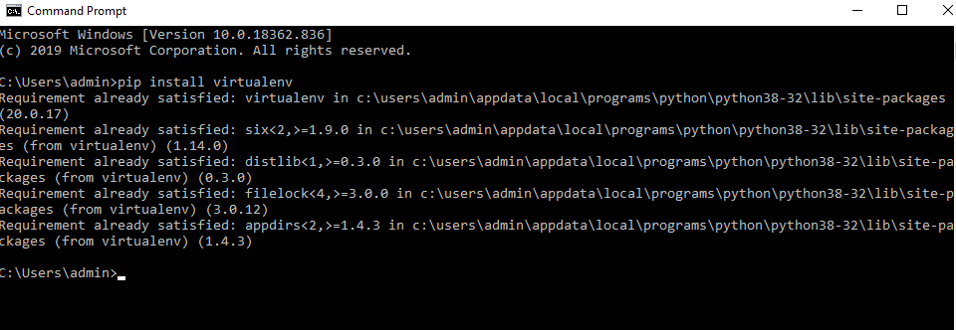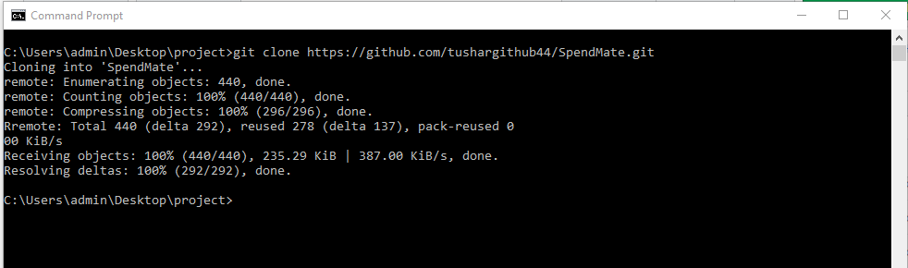

1. Go to project directory :

**cd SpendMate**

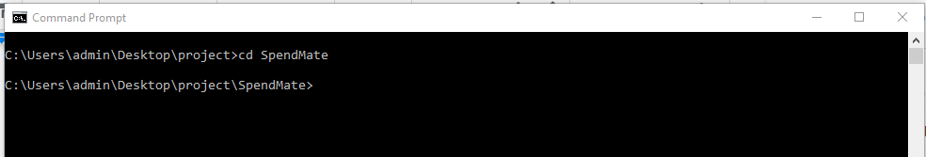

1. Create a virtual environment

**virtualenv env**

**Activate your virtualenv:**

**on Windows, virtualenv creates a batch file**

**cd env\Scripts**

**to activate virtualenv on Windows, activate script is in the Scripts folder :**

**Activate**

**Go back to root directory:**

**cd ../..**

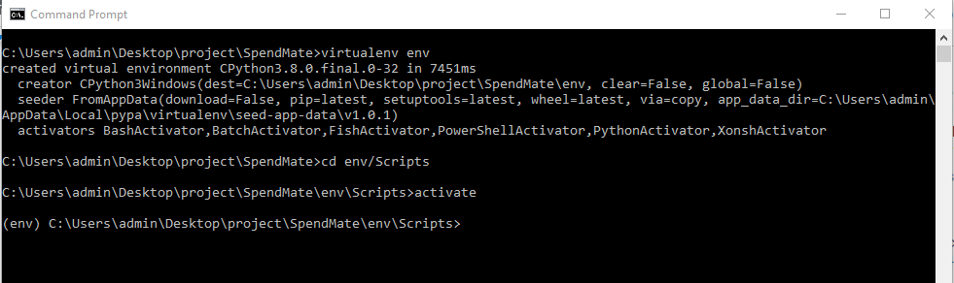

1. Download the dependencies :

**pip install -r requirements.txt**

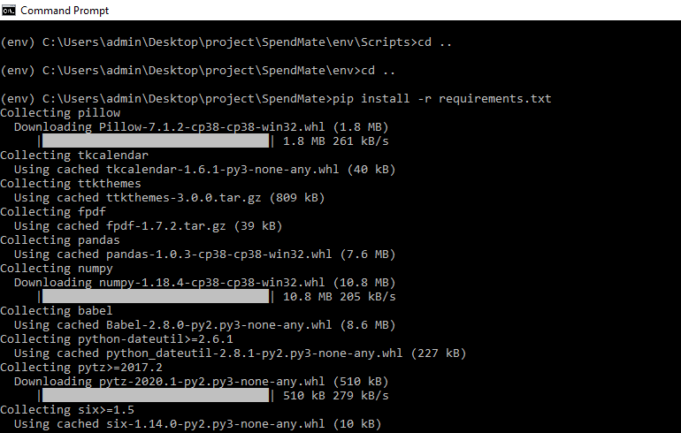

1. Run code:

**python app.py**

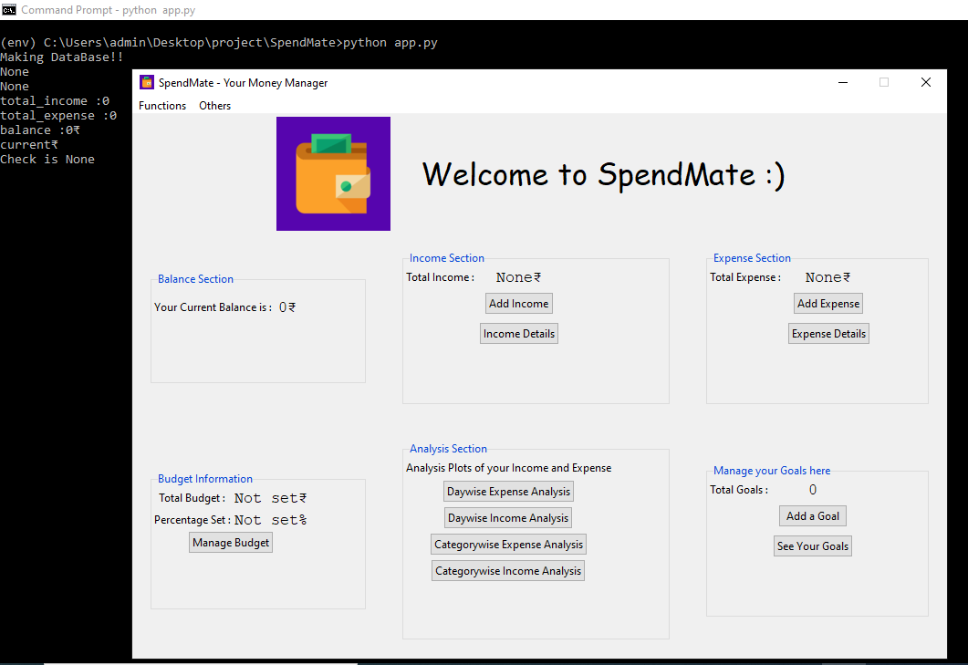

**This is when you start the Application for the first time :**

**MenuBar:**

**Functions:**

1. **Categories**

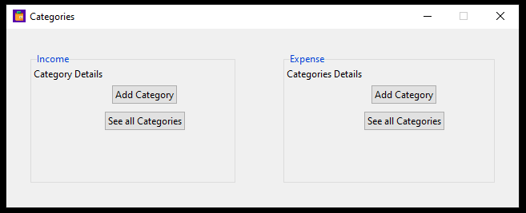

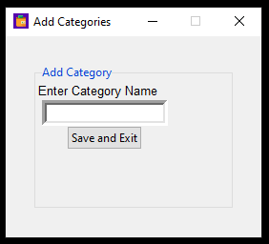

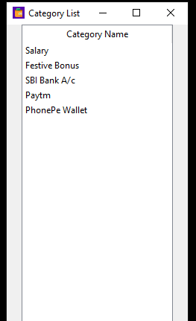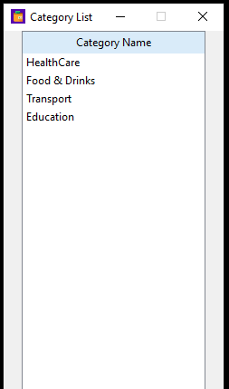

1. **Set Currency**

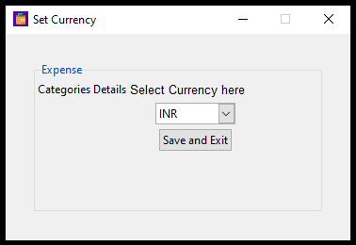

1. **Account**

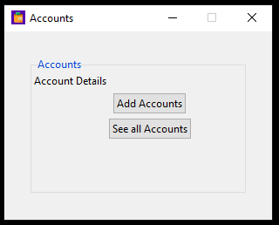

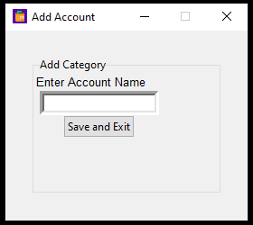

1. **Report**

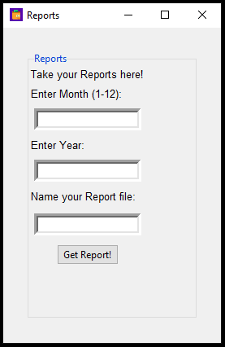

**It generates a report of your database as a pdf file and is available in root directory.**

**Example :**

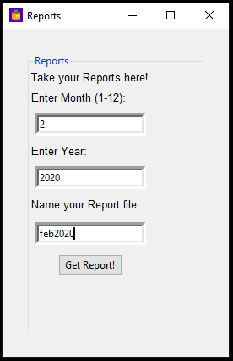

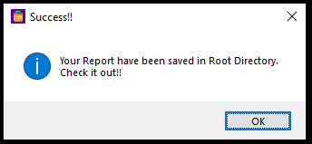

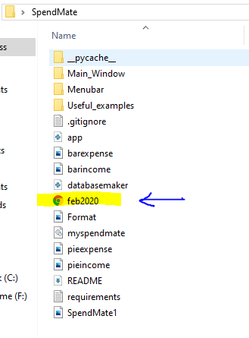

**Others:**

1. **Feedback**

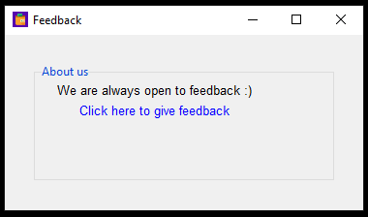

1. **About us**

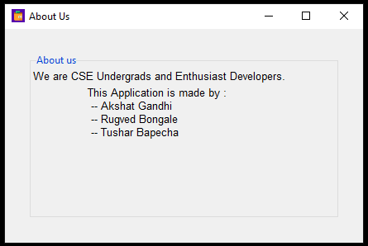

1. **Help**

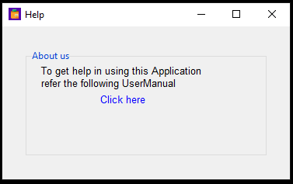

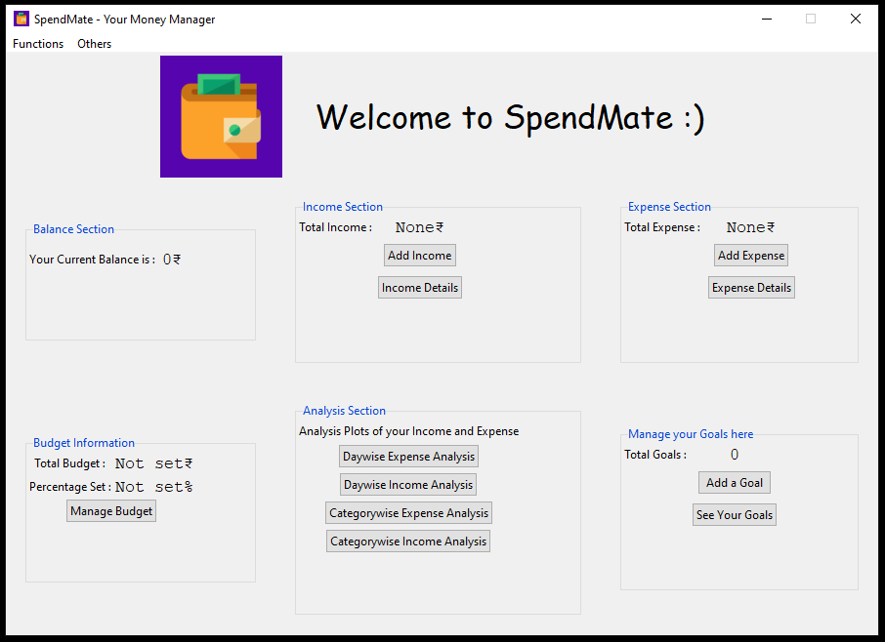

**Balance Section:** This is where the current balance is displayed

* Initially when no income or expense is added →

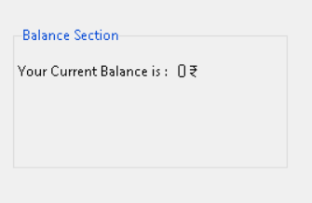

**Income Section:** This where the user can add their income/amount as well as get the detailed list of all the amount the user has added.

* Initially when no income is added →

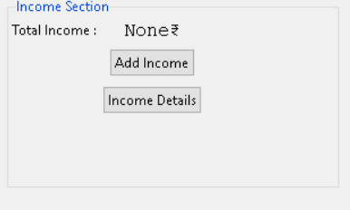

* How to add → **Click on Add Income button and fill the details**

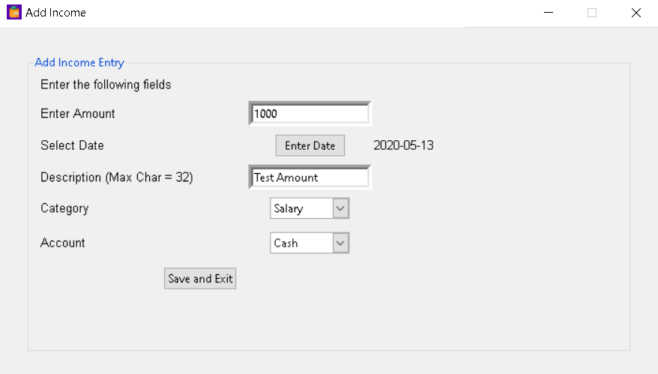

**Click on Save and Exit**

* **Updated Screen**

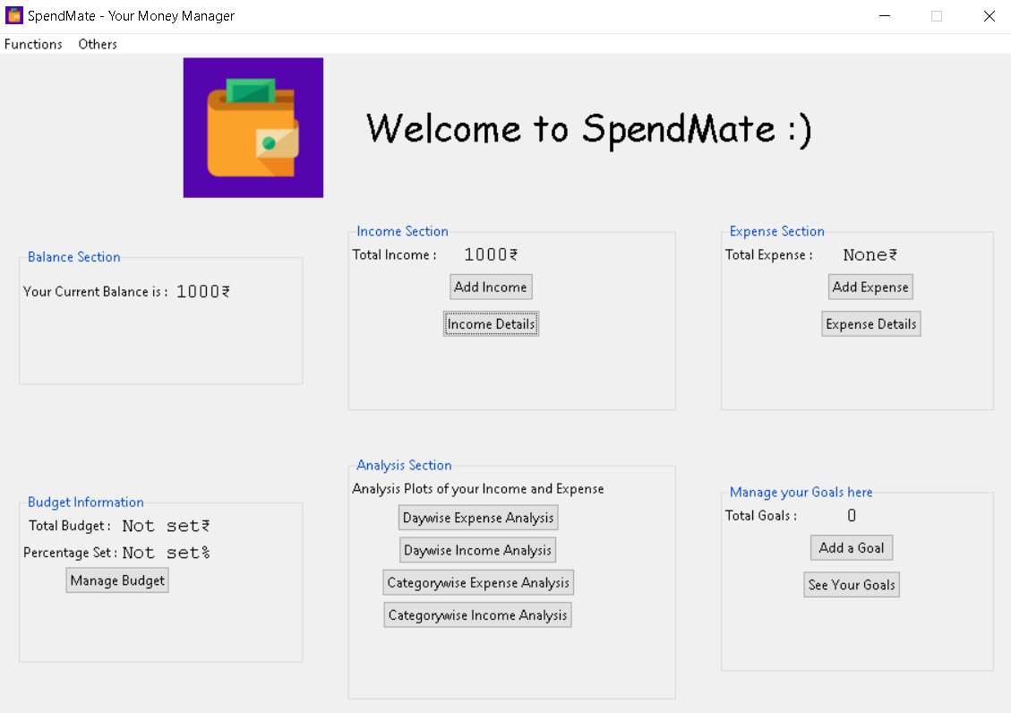

* Click on **Income Details**

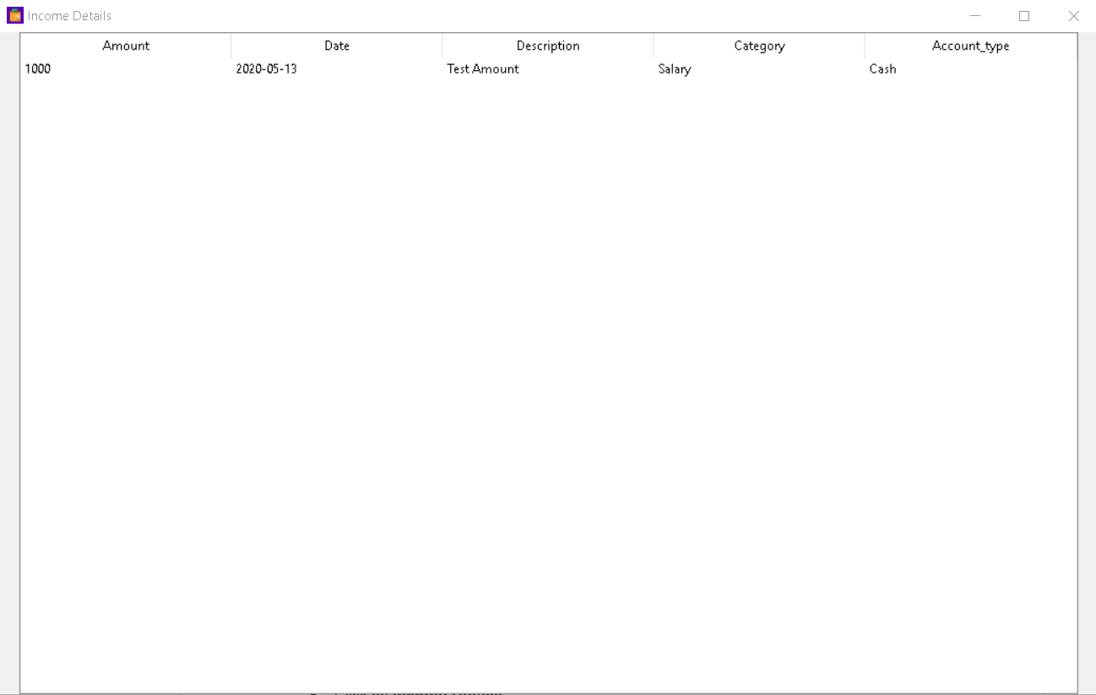

The details of the amount added can be seen above.

**Expense Section:** This where the user can add their expense as well as get the detailed list of all the expenses the user has added.

* Initially when no expense is added →

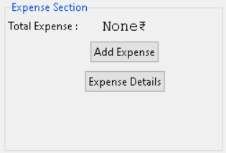

* How to add → **Click on Add Expense button and fill the details**

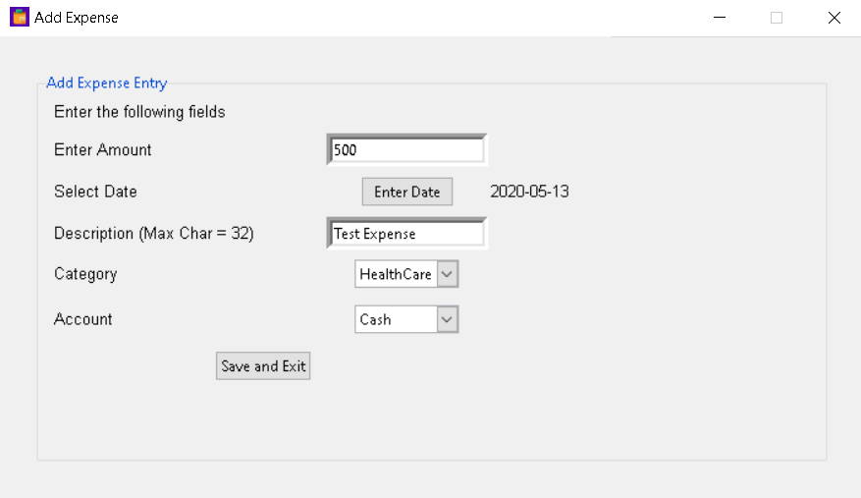

**Click on Save and Exit**

* **Updated Screen**

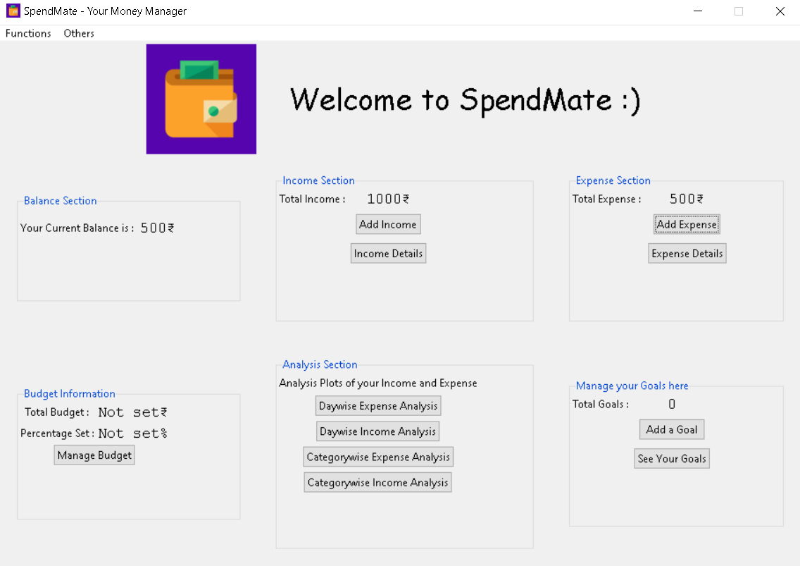

* Click on **Expense Details**

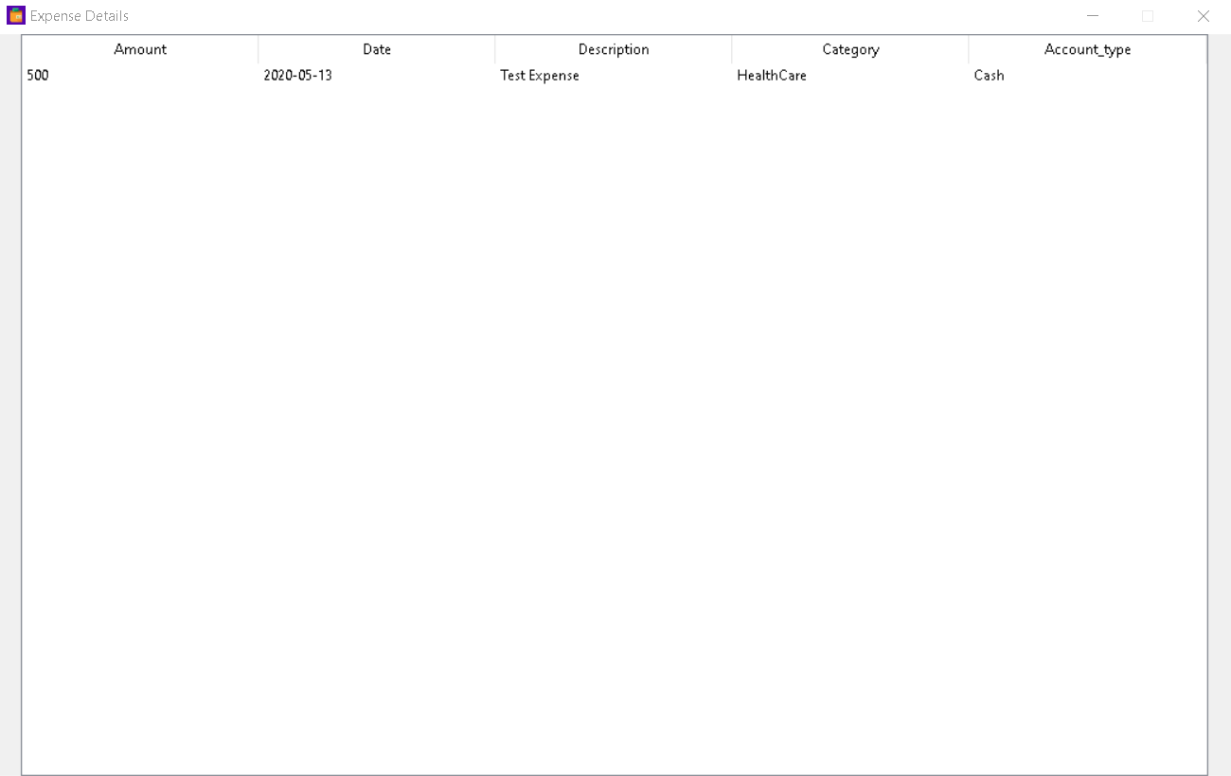

The details of the expense added can be seen above.

**\*** For the previews of the sections given below some more dummy data are added :

**The details of dummy Income added :**

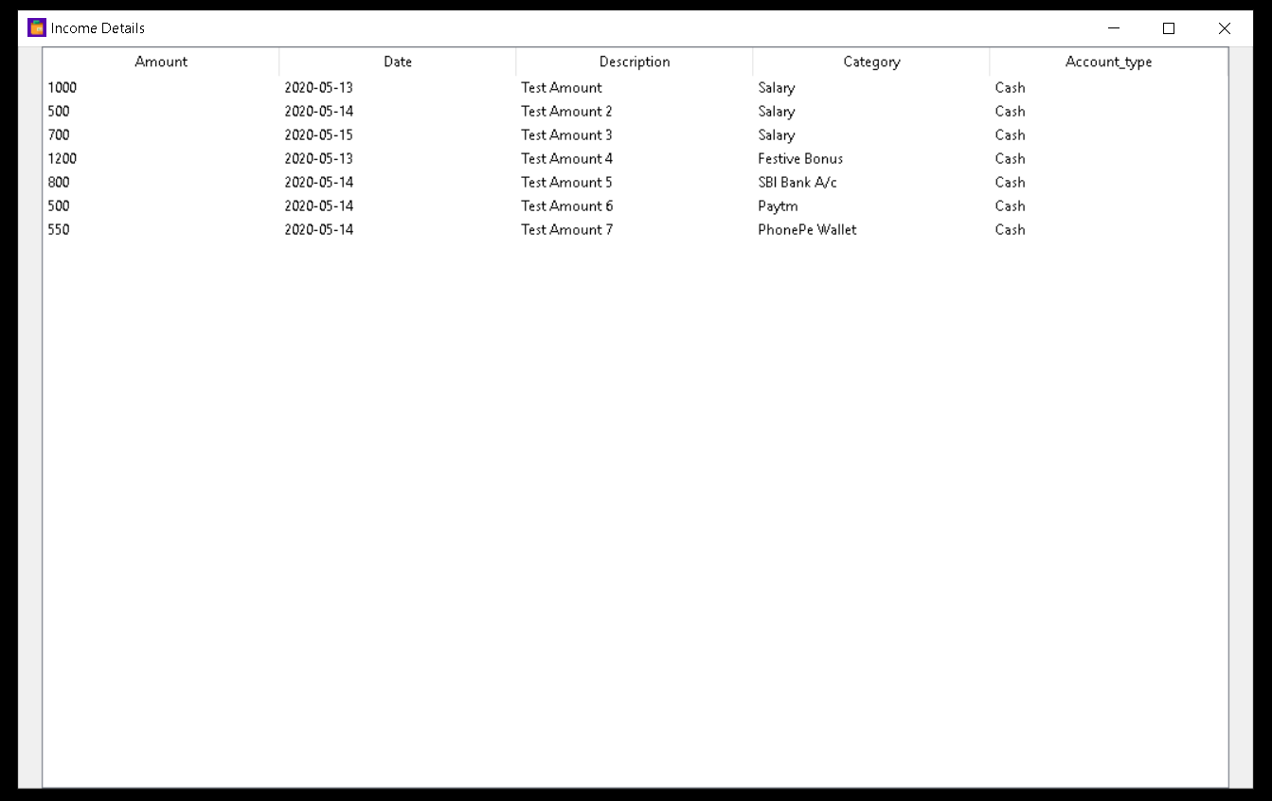

**The details of dummy Expense added :**

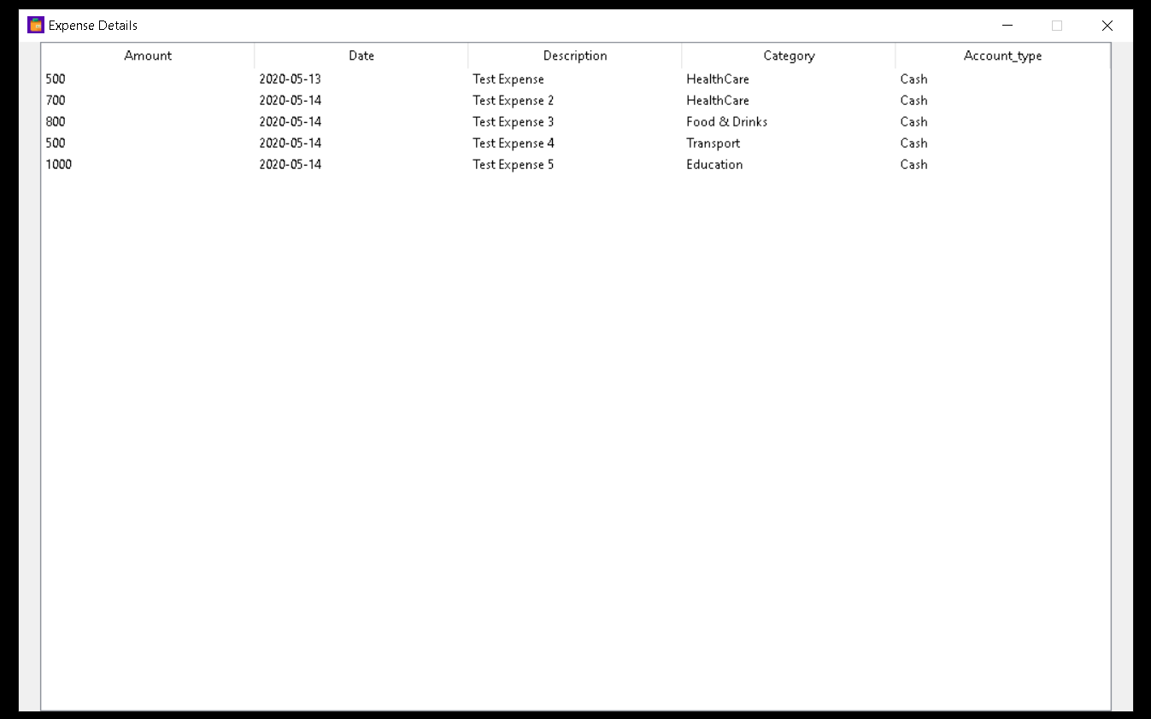

**Analysis Section:**

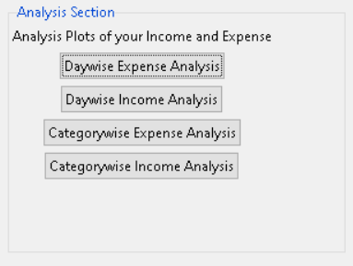

* **Daywise Expense Analysis:**
  + Select the **Daywise Expense Analysis** option

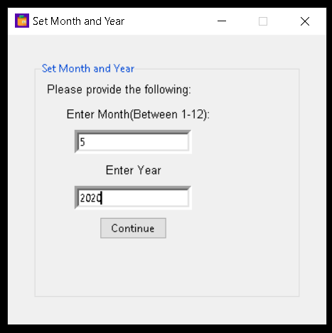

* + Enter the respective month and year and select **Continue**

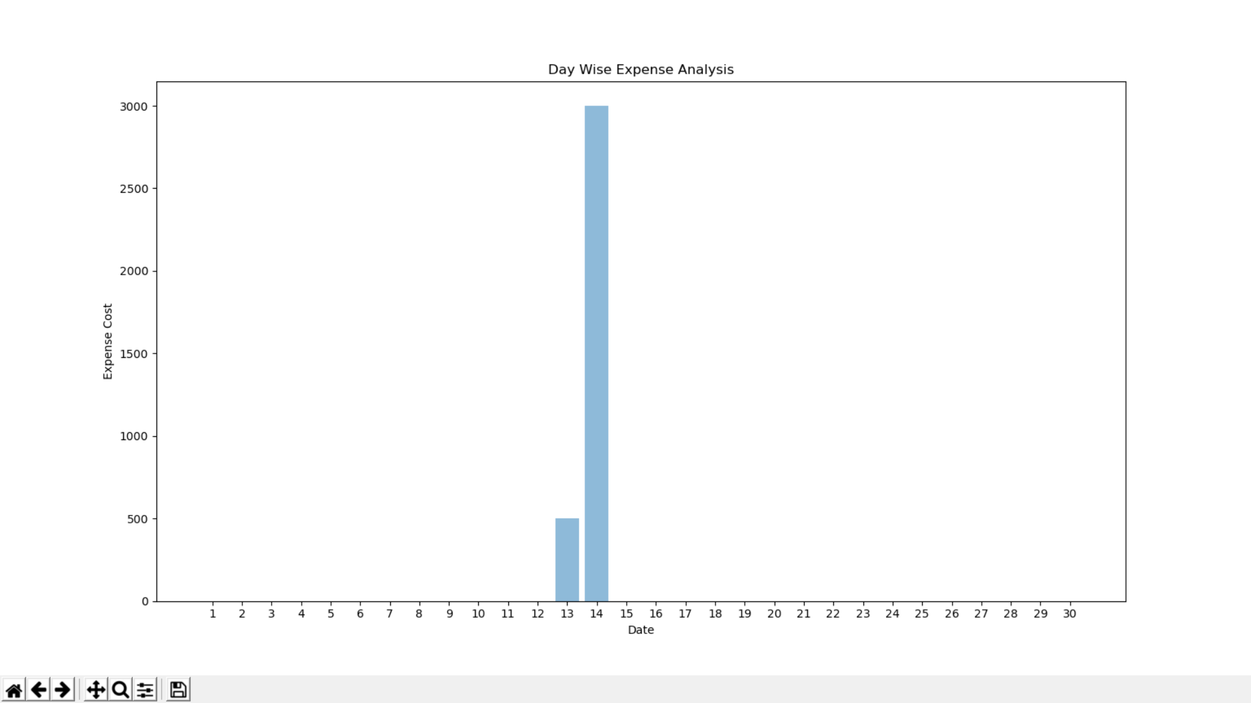

* + **Various options to manipulate and save this graph**



* **Daywise Income Analysis:**
  + Select the **Daywise Income Analysis** option

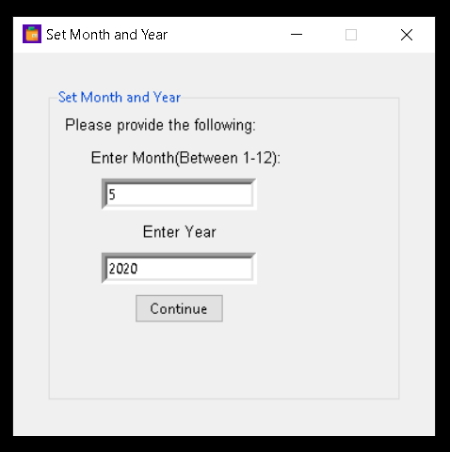

* + Enter the respective month and year and select **Continue**

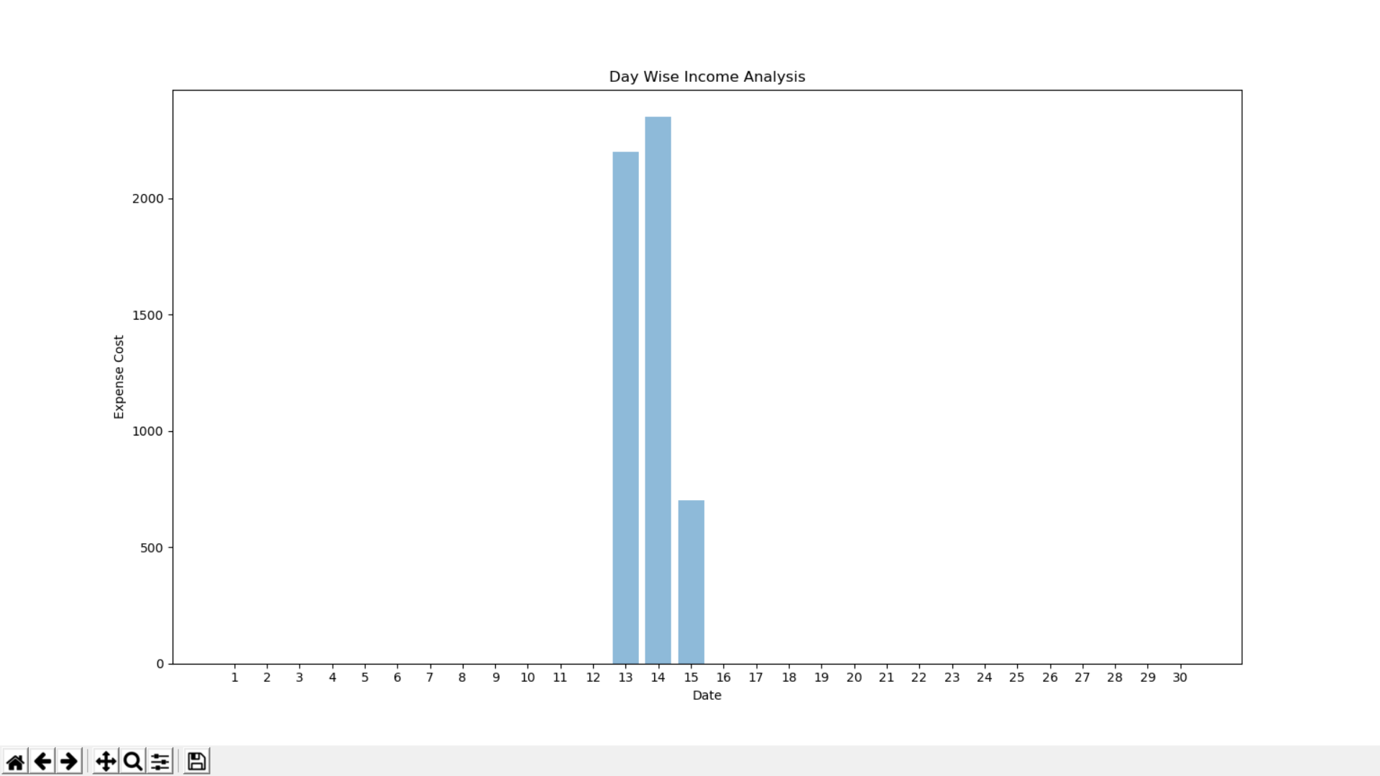

* **Categorywise Expense Analysis:**
  + Select the **Categorywise Expense Analysis** option

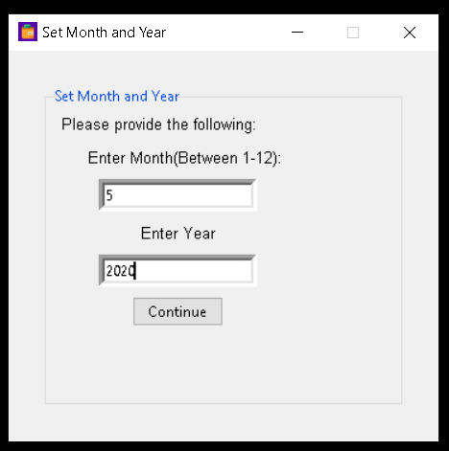

* + Enter the respective month and year and select **Continue**

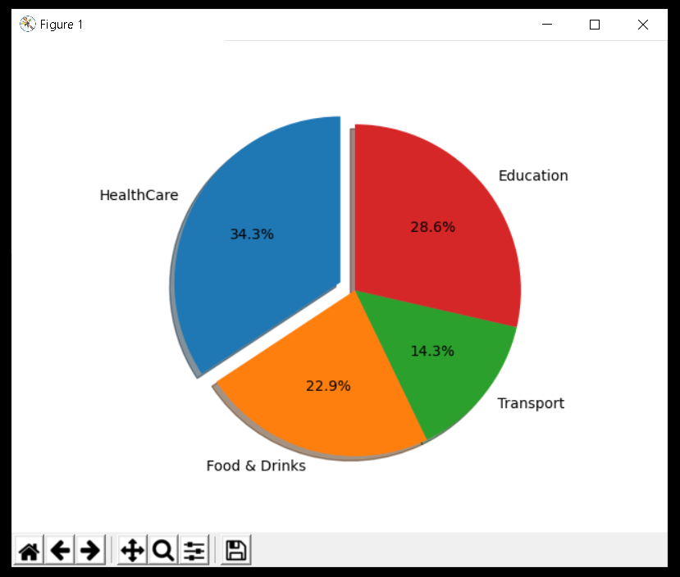

* **Categorywise Income Analysis:**
  + Select the **Categorywise Income Analysis** option

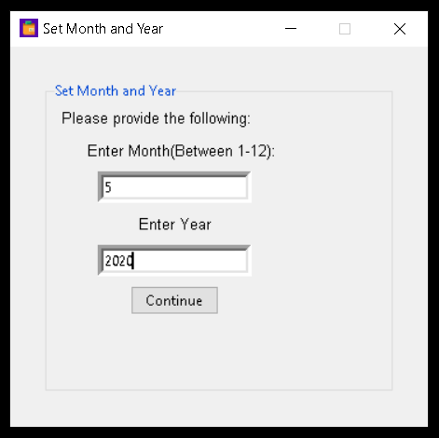

* + Enter the respective month and year and select **Continue**

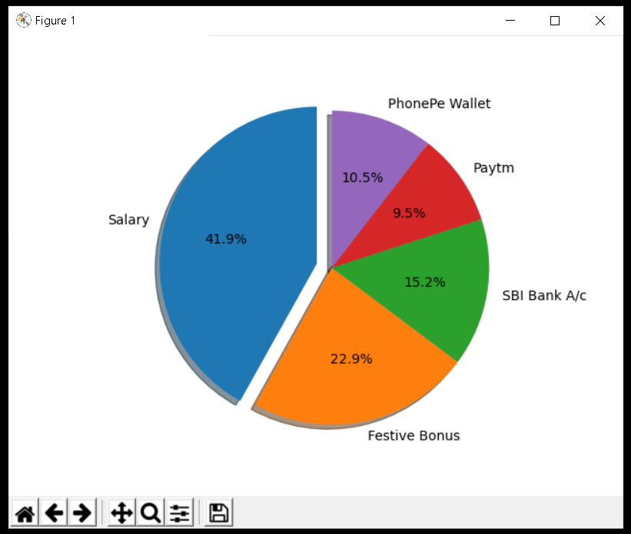

**Budget Information:**

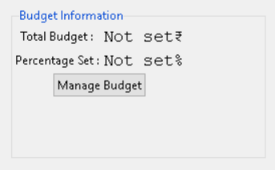

* Click on **Manage Budget** to set the details of your budget

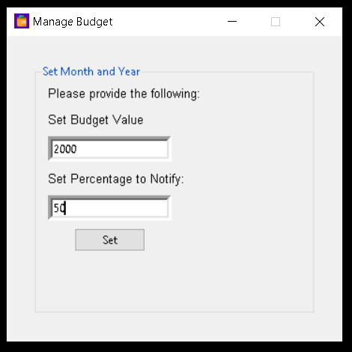

* **Set Budget Value** **-** The amount you want to allocate to your budget
* **Set Percentage to Notify -** Once, the **Total Expense exceeds the set percentage of the budget value** an alert message on your main window will appear.

**Currently →** As **Total Expense= 3500** which exceeds 50 percent of our budget, there will be an alert message

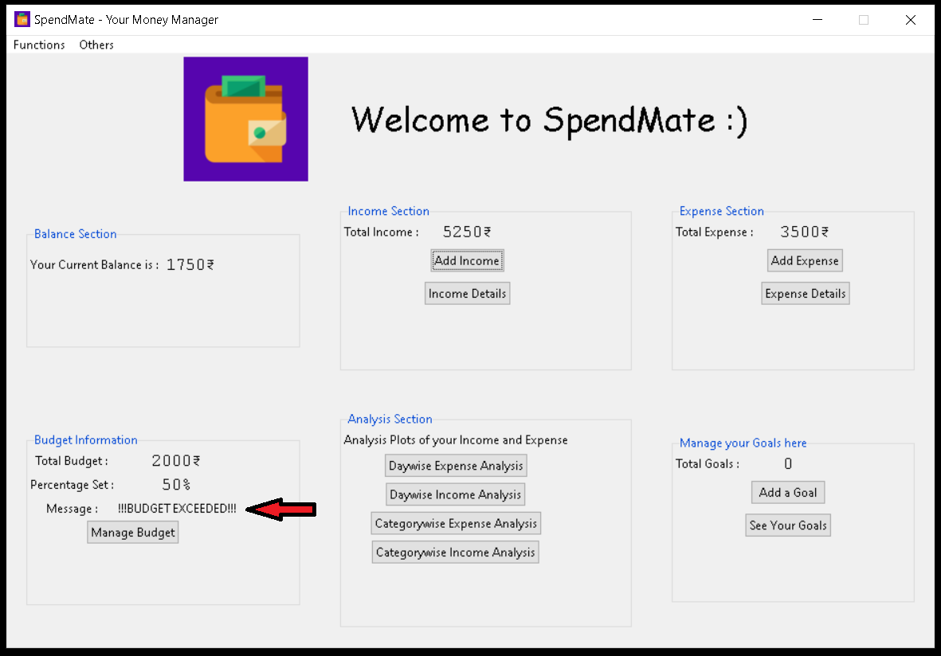

If we increase our budget, then the alert message **“!!!BUDGET EXCEED!!!”** will be changed to **“Budget under control”**

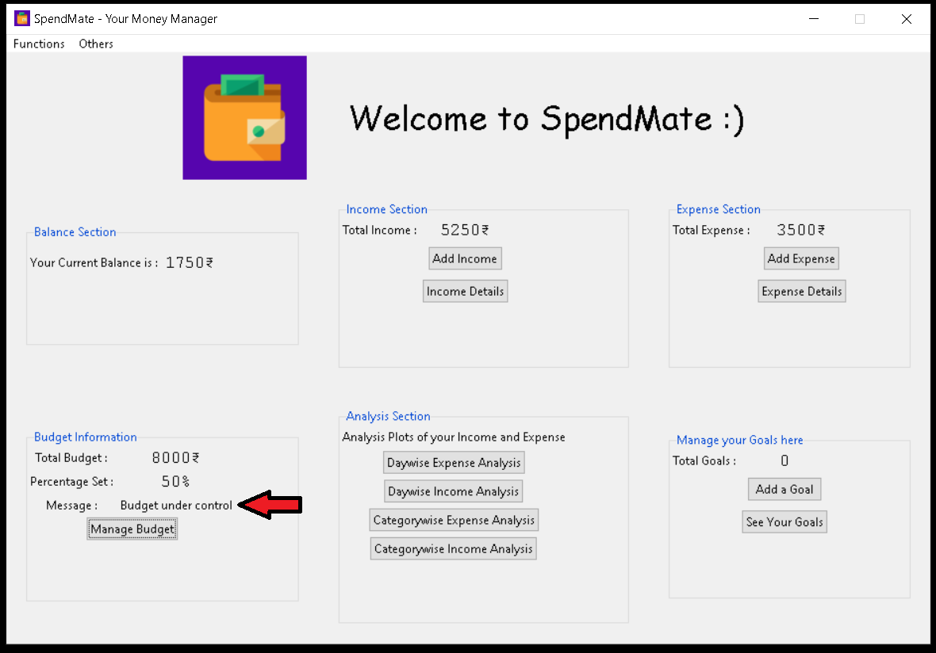

**Manage your Goals here:**

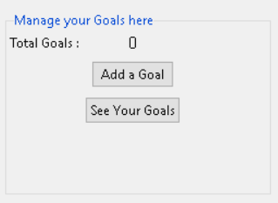

* Select the **Add a Goal** option

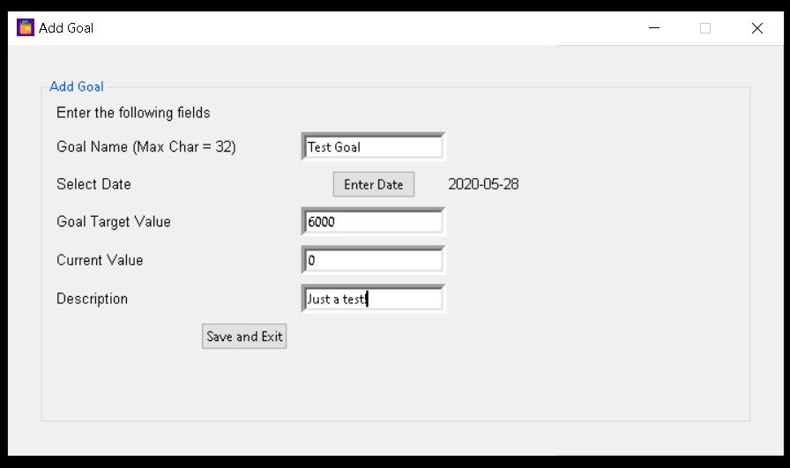

**Goal Name** - Enter the name of your goal

**Select Date** - Select the date by which you want to achieve your goal

**Goal Target Value** - Enter the amount of your goal

**Current Value** - Enter your current value which you have saved for your goal

**Description** - Enter the description of your goal

**Click on Save and Exit**

**Updated Screen :**

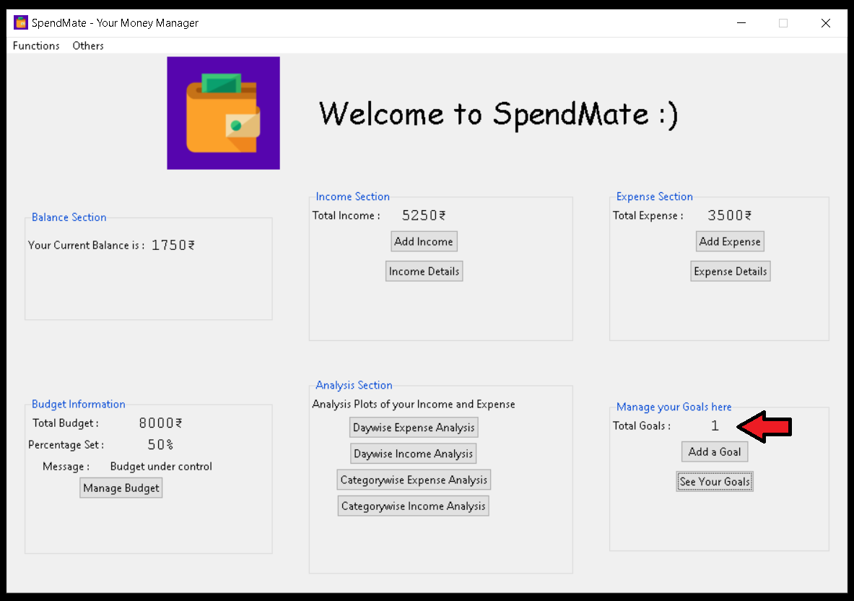

**Total Goals** has been updated now.

* Select **See Your Goals** option to view all the details of all your goals

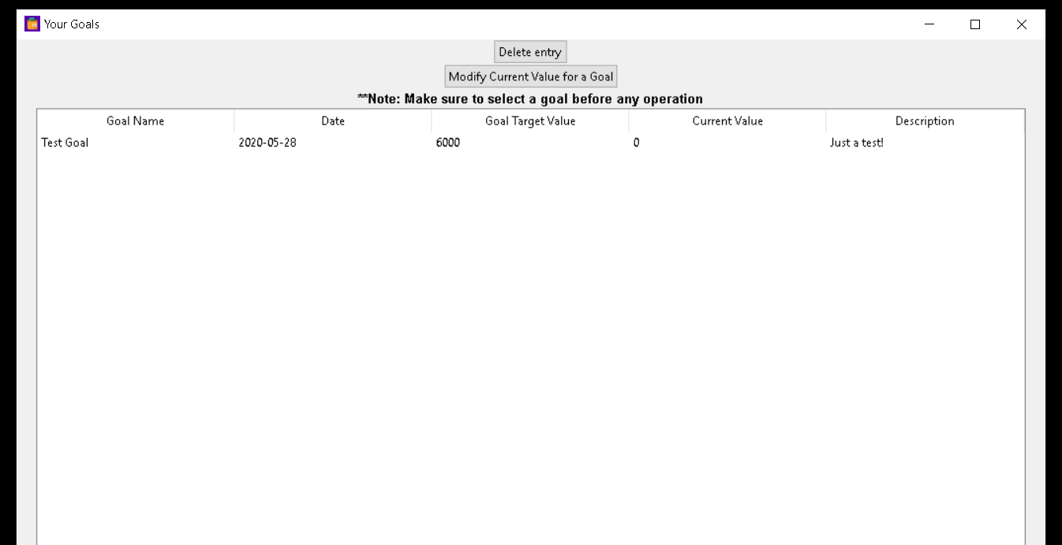

* Select **Modify Current Value for a Goal** option to modify current value of your goal.

**(* Don't forget to select your goal first and then click on the option)**

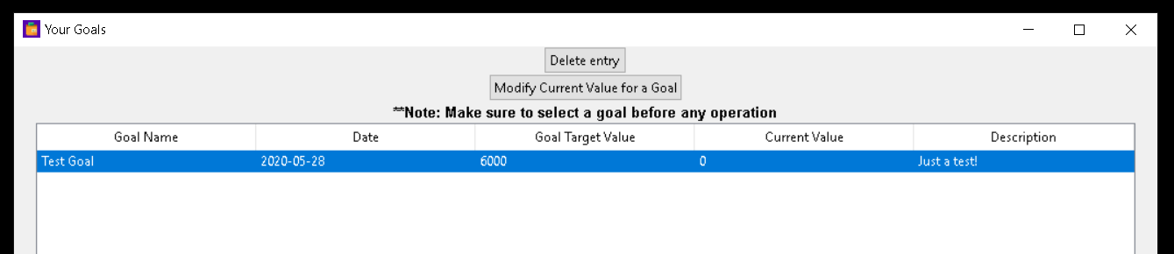

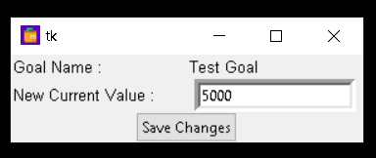

**Click on Save Changes**

**Test Goal’s** current value has been updated now

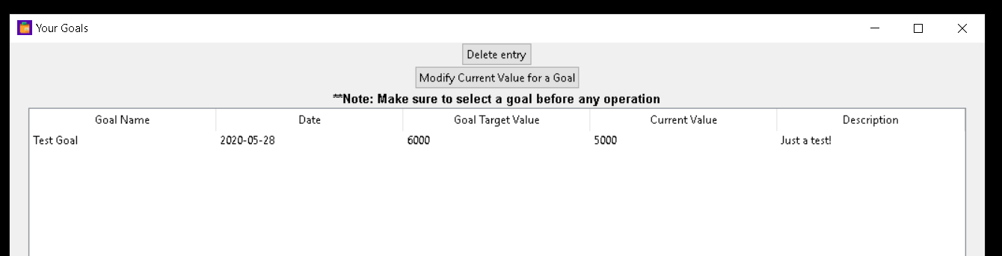

* Select **Delete entry** option to delete your goal.

**(* Don't forget to select your goal first and then click on the option)**

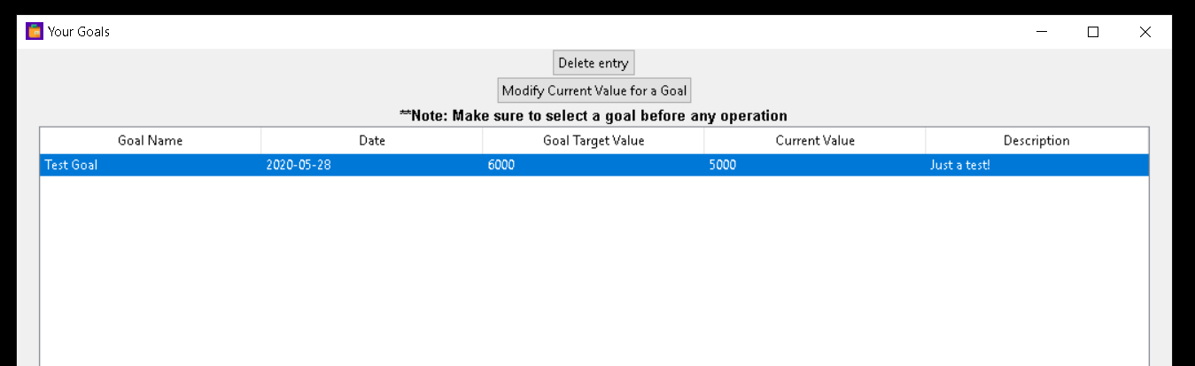

Your Goal has been deleted!

**Test Goal’s** current value has been updated now

